Table of Contents
Table of Contents 2
Key 2
Introduction 2
Domain Properties 4
Domain Name & TLD 4
Domain Age & Ownership 5
SSL certificate & HTTPS/HTTP Issues 5
Preferred Domain & Trailing Slashes 6
301 redirects & 404 errors 8
301 Redirects 8
404 Errors 10
Functioning 404 Page 11
Google Properties 13
Analytics 13
Search Console 15
Google Algorithm 15
Google Data Analysis 16
Total Users 17
New Users vs Returning Users 18
Users by Country 19
User Source Type 20
Mobile vs Desktop 22
Site Speed 24
Bounce Rate 25
Time Spent per Session 27
Total Impressions vs Total Clicks 28
Average Click Through Rate (CTR) vs Average Position 30
Recommendations 30
Technical SEO 30
Low Value Pages, Indexing, & Robots.txt 31
XML Sitemap 33
Duplicate Content & Canonicalisation 34
Structured Data & Rich Results 35
Mobile Friendliness 36
Speed Test & Performance 38
Security Check & Malware Scan 41
Website Structure & Depth 42
Content Management System 43
General CMS 43
Yoast 44
Plugins 45
Summary and Conclusion 46
Areas for Improvement 46
Domain 47
301 Redirects & 404 Errors 47
Google 47
Technical SEO 48
CMS (WordPress) 48
Appendix: References and resources 49

Key

Green - Done well / trivial room for improvement
Orange - Done poorly / room for improvements
Red - Current state is detrimental to overall SEO / completely unimplemented
Blue - Our recommendation

Introduction
SEO services can play a crucial role in building visibility, brand awareness, traffic, and sales from organic search. We take an active step in understanding your business, its branding and positioning. There are over 200 ranking factors to Google’s algorithm.

Our approach focuses on targeting those factors that have the most influence, and those that will have the biggest return on investment.

A complete SEO Audit consists of three components:
- Technical / sitewide problems
- Content / on-page / page-specific problems
- Off-page / competitor problems.

This Technical Audit will deal with aspects relating to:
- The Domain (such as domain resolve problems or a lack of SSL),
- Your relationship with Google (ie. Google Analytics being set up poorly or Google My Business lacking details),
- Various Technical SEO properties (ie. slow site speed or a broken XML sitemap), and
- Wordpress specific characteristics (such as missing or outdated plugins).

We use premium tools and a methodological approach to consider a broad spectrum of metrics. We will provide you with a snapshot of the health of your website, pinpoint any problems, and suggest remedies to these problems.

This report can be used as either a basis for a retainer, or as a blueprint for your internal development team to resolve any technical issues to grow your site’s traffic.

Domain Properties

DOMAINl
lPROPERTIESl

Your domain is an important aspect of your website. It can help with brand recognition and indicate if you are country-specific. Mistakes in domain resolve and SSL can have strongly negative impacts on the SEO of your site.

Domain Name & TLD
Domain names are an important part of a successful website. In a domain you have 3 choices, each with their own pros and cons:

- Exact match domains eg websitedesign.co.za (EMD)
- Partial match domains eg: wowwdesign.co.za (PMD)
- Branded domains eg: woww.co.za (BD)
- TLD (Top Level Domain eg: .com / .co.za / .org)

 | TLD (top-level domain)  A TLD identifies something about the website associated with it, such as its purpose, the organization that owns it or the geographical area where it originates.
Generally your domain name and TLD will not be a problem. However, there are some cases where they can cause issues. For example, if you are targeting multiple markets internationally then you should have a generic (e.g. “.com”) TLD instead of a local (e.g. “.co.za”) TLD.

FINDINGS: https://www.pikelandpropertygroup.com/

- N/A
- You have a partial match branded domain
- You have an international generic TLD (.com), which is appropriate for the brand and market.
- n/a

RECOMMENDATIONS
- None

Domain Age & Ownership
This measures your domain’s age and owner information. Having ownership details that match your site’s content is preferable and an older domain is easier to rank.

Older domains tend to acquire backlinks over the years and get crawled by lots of systems. They are also considered to be more trustworthy as they have been around longer and have proven themselves as a reputable domain, unlike a fresh domain which could have been created with the intent of generating spam.

FINDINGS

- Your domain was registered on 25 March 2022. See here for more details.
- N/A
- N/A

RECOMMENDATIONS
- None.

SSL certificate & HTTPS/HTTP Issues
One of the most important components of online business is creating a trusted environment where potential customers feel confident in making purchases, sending enquiries or simply navigating your website.

SSL certificates create a foundation of trust by establishing a secure connection. To assure visitors their connection is secure, browsers provide visual cues, such as a lock icon or a green bar. Google has indicated that it rewards SSL sites over non-SSL sites.

 | SSL  Stands for "Secure Sockets Layer." SSL is a secure protocol developed for sending information securely over the Internet. Only the user's computer and the secure server are able to recognize the data.

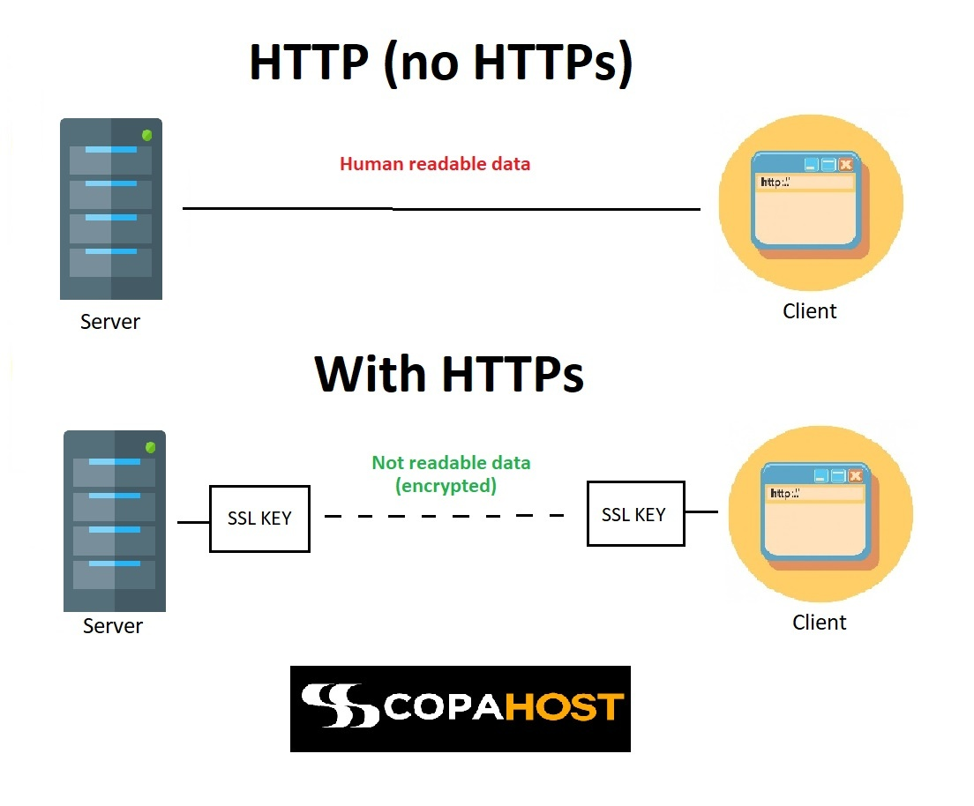

Source: Copahost

DATA COLLECTION

 | Internal links to HTTP

FINDINGS

- Your site has an active and correctly configured SSL certificate.
- Both HTTP domain variants redirect to HTTPS equivalents.
  - HTTP versions of the root and www domains return 301 redirects to HTTPS.
  - No indexable HTTP pages were found.

RECOMMENDATIONS
- None.

Preferred Domain & Trailing Slashes
Preferred domain refers to whether your domain has only 1 active variation. This means that you choose 1 variation of your domain and then redirect the other 3 variations to this preferred variation.

If you have multiple versions of your domain then you will not rank as well as you could (because Google will consider your content to be duplicate content, thus diluting your ability to rank).

Example:
The “root with SSL” domain was chosen to be the preferred domain for Woww, and thus all other domain variations are redirected to the preferred domain.

- “http://woww.co.za/” (This is called the root domain)
- “http://www.woww.co.za/” (This is the www domain)
- “https://www.woww.co.za/” (This is the www with SSL)
- “https://woww.co.za/” (This is the root with SSL)

Trailing slashes refers to whether your URLs end with a “/” or not, and whether you are consistent in your approach regarding trailing slashes.

Poorly implemented trailing slashes can be extremely damaging because Google views (e.g.) https://woww.co.za/about/ and https://woww.co.za/about as different pages, and so you can slip down the search results for duplicate content if you have both versions of a URL on your site.

DATA COLLECTION

 | URL crawl - Pikeland Property Group

FINDINGS

- The preferred site version is https://www.pikelandpropertygroup.com/.
- The non-www HTTPS homepage redirects with a 301 to the preferred www HTTPS version:
  - https://pikelandpropertygroup.com/
  - https://www.pikelandpropertygroup.com/
- The URL crawl shows that indexable HTML pages consistently use trailing slashes, for example:
  - https://www.pikelandpropertygroup.com/faq/
  - https://www.pikelandpropertygroup.com/how-we-buy-houses/
  - https://www.pikelandpropertygroup.com/contact-us/
  - https://www.pikelandpropertygroup.com/sell-your-house-fast-in-philadelphia-pa/
- The URLs without trailing slashes are expected technical or file URLs, rather than indexable HTML pages:
  - https://www.pikelandpropertygroup.com/wp-login.php
  - https://www.pikelandpropertygroup.com/wp-content/uploads/2023/07/How-To-Stop-Foreclosure-Guide.pdf
  - https://www.pikelandpropertygroup.com/wp-content/uploads/2023/07/Selling-To-A-Real-Estate-Investor.pdf
- n/a.
- n/a

RECOMMENDATIONS
- No critical issues..
  - Keep https://www.pikelandpropertygroup.com/ as the single preferred hostname.
  - Maintain permanent 301 redirects from the non-www and HTTP variants to the preferred www HTTPS version.
  - Continue using trailing slashes for indexable HTML pages. Do not force trailing slashes onto file URLs such as PDFs or technical endpoints such as wp-login.php.
  - Ensure internal links, canonical tags, XML sitemap URLs, and structured data URLs consistently use the preferred www HTTPS version with the correct trailing-slash format.
  - Recheck redirects, canonicals, and sitemap output after WordPress, plugin, theme, or hosting changes.


301 redirects & 404 errors
l301 REDIRECTS &l
l404 ERRORSl
For most sites, 301 redirects and 404 errors won’t be a huge issue. However, if you have a large number of them or some systemic problem which generates them, then they can become a significant issue.

301 Redirects
301 redirects cause a user (or search engine crawler) to be redirected from a URL to another URL. They can be useful, e.g. by redirecting users from http versions of your site to https (i.e. secure) versions of your site. However, 301 redirects can also harm the ability of your site to rank on Google, because they can worsen performance and are used in spam tactics .

One way in which a 301 redirect can harm your site is if the redirect is unnecessary. For example: your homepage internally links to an http page which is then redirected to the https page - you should just have linked directly to the https page (and avoided the unnecessary 301 redirect).

Another way in which 301 redirects can harm your site is redirect chains. For example: the “www” domain redirects to the “root” domain which redirects to the “root with SSL” domain - this redirect chain could be avoided by redirecting the www domain to the root with SSL domain directly.

We used Ahrefs to crawl your site. We then analysed the Ahrefs data with regard to 301 redirects and redirect loops.

DATA COLLECTION

 | 301 redirects - Pikeland Property Group
 | Redirect Chains - Pikeland Property Group
 | Pages with internal links to 301 redirects - Pikeland Property Group

FINDINGS

- The crawl identified 10 URLs returning a 301 status code. All redirect directly to a final 200-status URL, with no multi-step redirect chains identified.

- The HTTP homepage correctly redirects to the preferred HTTPS homepage:
  - http://www.pikelandpropertygroup.com/
  - https://www.pikelandpropertygroup.com/
- Eight WordPress/Avada taxonomy URLs return 301 redirects to the homepage and are included in the XML sitemap:
  - /blog/fusion_tb_category/header/
  - /blog/fusion_tb_category/content/
  - /blog/fusion_tb_category/page_title_bar/
  - /blog/fusion_tb_category/footer/
  - /blog/element_category/elements/
  - /blog/element_category/sections/
  - /blog/element_category/post_cards/
  - /blog/element_category/columns/
- One FAQ taxonomy URL redirects to the relevant live page:
  - /blog/faq_category/how-we-buy-houses/
  - /how-we-buy-houses/
- One old FAQ-category URL redirects to a relevant live page:
  - https://www.pikelandpropertygroup.com/blog/faq_category/how-we-buy-houses/ → https://www.pikelandpropertygroup.com/how-we-buy-houses/
- The primary issue is that redirected taxonomy URLs are included in the XML sitemap. A sitemap should contain only live, canonical, indexable URLs returning HTTP 200.
- N/A

RECOMMENDATIONS
- Retain the HTTP-to-HTTPS 301 redirect for the homepage.
- Remove the eight redirected Fusion Builder and element-category URLs from the XML sitemap.
- Disable or exclude the related Fusion Builder and element-category sitemap outputs where these taxonomies are not intended to rank.
- Keep the /blog/faq_category/how-we-buy-houses/ redirect in place, but remove any remaining internal or sitemap references to the old taxonomy URL.
- Re-crawl the site and resubmit the cleaned XML sitemap in Google Search Console after implementation.

404 Errors
A 404 error occurs when a user or search engine crawler tries to access a page which does not exist on your site. This can result in a frustrating user experience and a diminished SEO rating by crawlers.

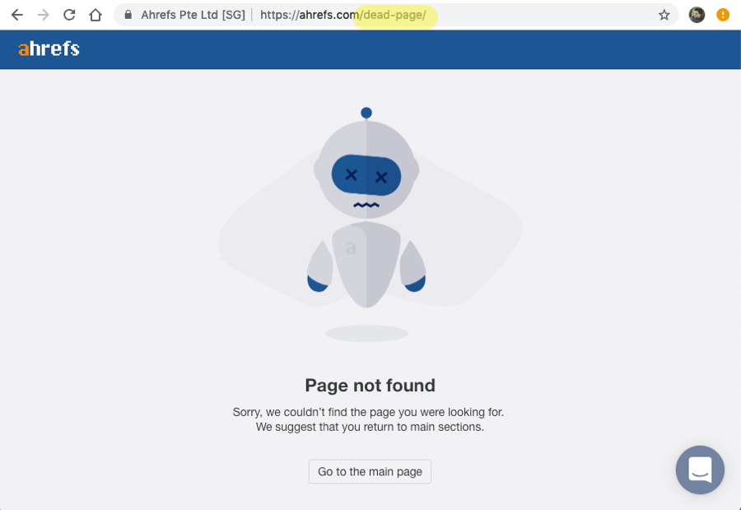ﬁ

Internal links (links on your own site) to 404 errors should be fixed. External links (links on other people’s sites) to 404 errors should be redirected (using a 301 redirect) to an appropriate page (if there is a lot of traffic flowing through the link).

We used Ahrefs to crawl your site. We then analysed the Ahrefs data with regard to 404 errors.

DATA COLLECTION

 | 404 errors - Pikeland Property Group
 | Pages with internal links to 404 errors - Pikeland Property Group

FINDINGS

- There are 3 URLs returning a 404 status code in the Pikeland crawl.
  - https://www.pikelandpropertygroup.com/stop-foreclosure/
  - https://www.pikelandpropertygroup.com/blog/faq_category/general/
  - https://www.pikelandpropertygroup.com/blog/faq_category/home/
- N/A
- The main issue is the broken /stop-foreclosure/ URL, which has 8 internal href links pointing to it.
  - These links come from city landing pages, including:/sell-your-house-fast-in-pottstown-pa/
    - /sell-your-house-fast-in-wilmington-de/
    - /sell-your-house-fast-in-reading-pa/
    - /sell-your-house-fast-in-lancaster-pa/
    - /sell-your-house-fast-in-philadelphia-pa/
    - /sell-your-house-fast-in-york-pa/
    - /sell-your-house-fast-in-coatesville-pa/
    - /sell-your-house-fast-in-phoenixville-pa/
      - The anchor text is mainly “Stopping foreclosure” or “stop foreclosure”.
- Two FAQ category URLs are being referenced through canonical links, but the canonical targets return 404:
  - Source: https://www.pikelandpropertygroup.com/faq_category/general/Canonical target: https://www.pikelandpropertygroup.com/blog/faq_category/general/
  - Source: https://www.pikelandpropertygroup.com/faq_category/home/Canonical target: https://www.pikelandpropertygroup.com/blog/faq_category/home/

RECOMMENDATIONS
- Fix the internal links pointing to /stop-foreclosure/.
  - If there is a current foreclosure page, update the city landing page links to point directly to the live URL.
  - If the intended replacement is /avoiding-foreclosure/, update the links to that page.
  - If /stop-foreclosure/ has historical SEO or referral value, add a 301 redirect to the most relevant live foreclosure page.
- Fix the canonical tags on the FAQ category pages.
  - https://www.pikelandpropertygroup.com/faq_category/general/ should not canonicalise to a 404 URL.
  - https://www.pikelandpropertygroup.com/faq_category/home/ should not canonicalise to a 404 URL.
  - Update these canonicals to self-reference or point to the correct live preferred FAQ/category URL.
After the fixes, recrawl the site to confirm all 3 URLs either return 200 or redirect cleanly to a relevant live page.

Functioning 404 Page
A 404 page displays when a page cannot be found on a website. According to Google, it should have the following criteria:

- Tell visitors clearly that the page they’re looking for can’t be found
- Use language that is friendly and inviting
- Make sure your 404 page uses the same look and feel (including navigation) as the rest of your site.
- Consider adding links to your most popular articles or posts, as well as a link to your site’s home page.
- Think about providing a way for users to report a broken link.
- Make sure that your webserver returns an actual 404 HTTP status code when a missing page is requested
It is important for users to know whether a page exists or not when they either click on a non-existent page or make a spelling mistake in the URL. A 404 page is the perfect way to redirect users back to the homepage or to the page they may have been looking for.

Google also recognises if you have a 404 page, and ranks you better for it.

FINDINGS

- The 404 page functions correctly.
  - Missing URLs return an actual 404 HTTP status code.
  - The page clearly tells users that the requested page cannot be found.
  - The page uses friendly, simple language: “The page you are looking for doesn’t exist.”
  - The 404 page uses the same look and feel as the rest of the Pikeland Property Group website.
  - Header navigation is present, including Home, About Us, How It Works, Reviews, FAQ, Contact, and Get My Free Offer.
  - The page includes a clear “Back to Homepage” button.
  - The page includes footer navigation and a lead capture form, giving users additional ways to continue their journey.
  - The page returns a noindex, follow directive, which is appropriate for a 404 page.
- Minor improvements are still possible.
  - There is no visible option for users to report a broken link.
  - The page could include a few direct recovery links to high-value pages such as Get Your Offer, Contact, FAQ, and Reviews within the 404 content block itself.
- N/A

RECOMMENDATIONS
- Keep the current 404 setup in place because it is technically correct and user-friendly. Add a small broken-link reporting option, such as:
  - “Think this page should exist? Contact us and let us know.”
  - Link this to the Contact page or a support email.

- Consider adding secondary recovery links inside the 404 content area.
  - Get Your Offer
  - Contact Us
  - FAQ
  - Reviews
- Continue ensuring missing pages return a true 404 status rather than redirecting all missing URLs to the homepage.

Google Properties

lGOOGLEl lPROPERTIESl
Google search is one of the primary ways in which people find websites. Managing your relationship with Google is essential if you want Google to rank your pages highly in search results.

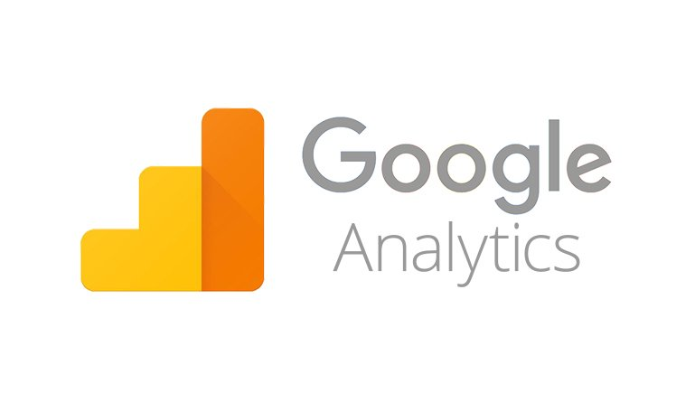
Analytics

Google Analytics is a free web analytics tool offered by Google to help you analyze your website traffic.

Given that your website is the central hub of your digital presence, your website is the best way to give you a holistic view of the effectiveness of all the campaigns you are running to promote your product/services online.

Google Analytics is a way to measure the site's traffic and gain insight into how users perform, where they are coming from and how they’re interacting with your site from both a holistic viewpoint all the way down to analysis of a single interaction.

FINDINGS

- Site has properly tracking Google Analytics Property:
  - GA4: G-42PZ2GBJLL
- The preferred URL is configured correctly.
- Your GSC is linked to your GA
- Your e-commerce and goals are set up.
- Your Google Ads is linked to your GA.
- Site Search, bot exclusion, & demographics have been enabled.
- N/A
- N/A

RECOMMENDATIONS
- N/A


Search Console
Search Console tools and reports help you measure your site's Search traffic and performance, fix issues and make your site shine in Google Search results.

FINDINGS

- N/A
- Google Search Console was not set up prior to the audit so not data has been collected yet for analysis. We are always happy to complete this analysis at a later date.
- N/A

RECOMMENDATIONS
- Google Search Console was not set up prior to the audit so not data has been collected yet for analysis. We are always happy to complete this analysis at a later date.

Google Algorithm
Google uses a machine-learning artificial intelligence system called “RankBrain” to help sort through its search results.This algorithm is periodically updated and sometimes has significant impact on search engine results.

FINDINGS

We’ve plotted your site’s traffic against some of the major updates for the last 2 years.
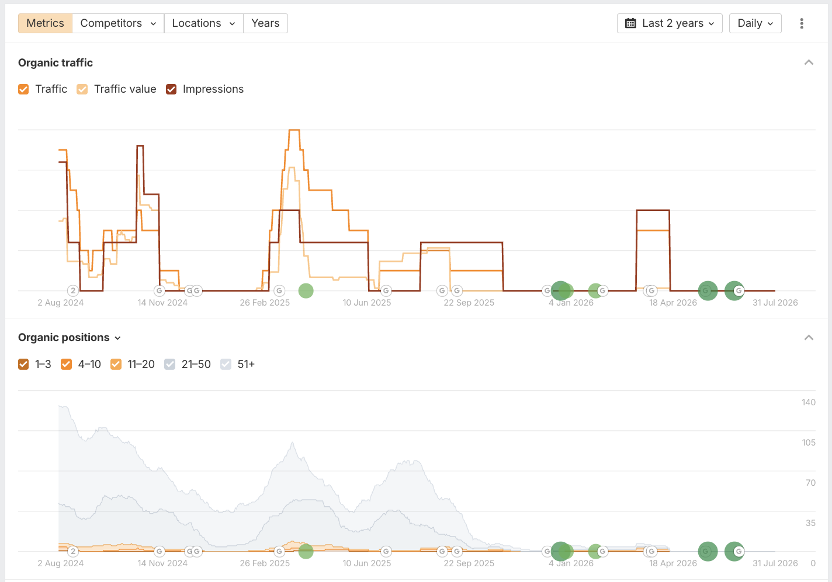
- No definitive impact from algorithm updates
  - While there does appear to be some kind of relation visually in the trendlines between Google updates (August 2024, and March 2025) and keyword rankings declining, the traffic figures were estimated to be very low during those periods and no keywords were ranking in the top 10 positions
- N/A
- N/A

 | SERPs  Search Engine Results Pages (also known as “SERPs” or “SERP”) are Google's response to a user's search query. SERPs tend to include organic search results, paid Google Ads results, Featured Snippets, Knowledge Graphs and video results.

RECOMMENDATION
- Increase EEAT within articles. Most competitors have author bios and dedicated pages. This will help us align closer with algorithm changes in late 2025.
- Create / optimise content in order to attract more traffic and keyword rankings
  - Follow the recommendations in the content ideas section of the content audit.

Google Data Analysis
In this section we will analyse your Google Analytics data and your Google Search Console data.

The Google Analytics data goes back 2 years (24 months) and is monthly data, while the Google Search Console data goes back 16 months and is daily data (this is a limitation of Google Search Console).

DATA COLLECTION

Google Data Analysis

FINDINGS

- n/a
- Google Analytics and Google Search Console were set up during the audit, meaning there is insufficient data to draw upon. This part of the audit can only be completed after a period of time (weeks or months).
- N/A

RECOMMENDATIONS
- Google Analytics and Google Search Console were set up during the audit, meaning there is insufficient data to draw upon. This part of the audit can only be completed after a period of time (weeks or months).

Total Users
This graph looks at the total raw number of users and returning users over time. This is one of the most basic metrics to consider: is your site becoming more popular? Often there are seasonal or annual cycles, which is why we look at 2 years (as looking at 1 year (or less) could lead to mistaking a cycle for a trend).

Screenshot not available - insufficient data

ANALYSIS
- Google Analytics and Google Search Console were set up during the audit, meaning there is insufficient data to draw upon. This part of the audit can only be completed after a period of time (weeks or months).

New Users vs Returning Users
The graph below shows the percentage of all users who are returning users over time. This is important because a decline in returning users could indicate that your site has become worse or that your competitors have become better.

Screenshot not available - insufficient data

ANALYSIS
- Google Analytics and Google Search Console were set up during the audit, meaning there is insufficient data to draw upon. This part of the audit can only be completed after a period of time (weeks or months).

Users by Country
This section looks at users by country. The map below is a screenshot from your Google Analytics dashboard - it can be found under Audience > Geo > Location. The map on Google Analytics is interactive and you can zoom into each country and see which province or region visits your website the most. This map is for the last 2 years of data.

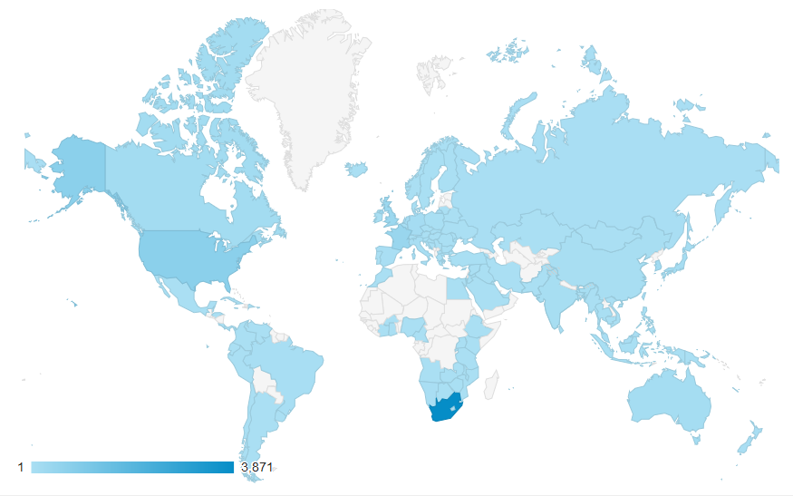

The bar chart below shows the top 10 countries by users. Note that the data labels won’t add up to 100% as a number of countries are excluded from the list.

Screenshot not available - insufficient data

ANALYSIS
- Google Analytics and Google Search Console were set up during the audit, meaning there is insufficient data to draw upon. This part of the audit can only be completed after a period of time (weeks or months).

User Source Type
This section looks at the raw number of sessions from different source types: paid (paid search), organic (non-paid search, i.e. finding the website through unpaid google search results), direct (i.e. typing the website URL directly into the browser), and referral (referral links).

The graph below looks at the raw number sessions by user source type.

Screenshot not available - insufficient data

ANALYSIS
- Google Analytics and Google Search Console were set up during the audit, meaning there is insufficient data to draw upon. This part of the audit can only be completed after a period of time (weeks or months).

The graph below shows the different source types as a percentage of total sessions. This is useful because looking at raw numbers alone will sometimes leave you without certain insights (especially e.g. if there is both a cycle and a trend in the data).

Mobile vs Desktop
This section shows your site’s traffic sources (looking at the raw number of sessions): desktop, mobile, and tablet. This is important because sites can work well on desktops and poorly on mobile, and so you want to know how much of your traffic is coming from mobile (and how it’s changing over time).

Screenshot not available - insufficient data

ANALYSIS
- Google Analytics and Google Search Console were set up during the audit, meaning there is insufficient data to draw upon. This part of the audit can only be completed after a period of time (weeks or months).

Bounce Rate
The bounce rate refers to the percentage of users who navigate away after viewing a single page. The average bounce rate is 40-55% and anything above 60% may indicate a problem.

The graph below compares the bounce rate of desktop users and mobile users. This is important because mobile and desktop experience may differ substantially leading to some users wanting to look at more pages and others leaving.

Screenshot not available - insufficient data

ANALYSIS
- Google Analytics and Google Search Console were set up during the audit, meaning there is insufficient data to draw upon. This part of the audit can only be completed after a period of time (weeks or months).

Time Spent per Session
The bar chart below compares desktop vs mobile time per session. It’s normal to have a fairly high percentage of sessions end in less than 10 seconds. This metric allows us to see just how engaged people are.

The bar chart below shows time per session comparing desktop and mobile.

Screenshot not available - insufficient data

ANALYSIS
- Google Analytics and Google Search Console were set up during the audit, meaning there is insufficient data to draw upon. This part of the audit can only be completed after a period of time (weeks or months).

Total Impressions vs Total Clicks
This dataset comes from Google Search Console, and thus only goes back 16 months (as opposed to going back 2 years like the rest of the data presented so far).

The graph below shows total clicks on the left axis and total impressions on the right axis. Note that the axes are different.

Total clicks refers to the total number of times a user clicks on a link to your website in the search results. Total impressions refers to the number of times a user saw a link to your website in the search results (this takes into account whether the link was scrolled into view or not).

ANALYSIS
- Google Analytics and Google Search Console were set up during the audit, meaning there is insufficient data to draw upon. This part of the audit can only be completed after a period of time (weeks or months).

Average Click Through Rate (CTR) vs Average Position
The graph below shows the average CTR on the left axis and the average position on the right axis. Note that the axes are different.

Average Click Through Rate refers to the percentage of impressions which result in a click. Average Position refers to the average position of your site in the search results.

ANALYSIS
- Google Analytics and Google Search Console were set up during the audit, meaning there is insufficient data to draw upon. This part of the audit can only be completed after a period of time (weeks or months).

Recommendations
RECOMMENDATIONS
- Google Analytics and Google Search Console were set up during the audit, meaning there is insufficient data to draw upon. This part of the audit can only be completed after a period of time (weeks or months).


Technical SEO
lTECHNICALl lSEOl
There are numerous aspects of a website which directly affect user experience as well as the ability of search engines to crawl the website. The aspects we consider here are typically sitewide rather than page specific, and fixing the problems should result in improvements across the site.

We crawled your website with a premium SEO tool called Ahrefs. The summary report created by Ahrefs is good for an overview of SEO topics, but is too superficial for detailed analysis of a particular topic. Do not overly pay heed to the health score as it is not a perfect metric.

Low Value Pages, Indexing, & Robots.txt
Google interacts with your website by: firstly, crawling your website (inspecting URLs and ‘clicking’ links); secondly, indexing your URLs (storing and organising your URLs); and thirdly, ranking your URLs against other relevant URLs.

Google has a limited ‘crawl budget’ for each website (the number of pages it will crawl), so you don’t want Google crawling too many low value pages. You also don’t want indexing too many low value pages. Google has directly stated that a large site with too many low value pages can experience worsened SEO.

Low value pages include:
- WordPress category/tag pages
- Duplicate content
- Content/blog posts which are low-quality or outdated
- Ecommerce product pages with zero sales
- Archive pages
- Print pages, sorted/filtered pages, other parameter pages
- Old services pages
- Orphan pages (pages with on incoming links)

A robots.txt is a text file that resides in the root directory of your website and gives search engine crawlers instructions as to which pages they can crawl and index. When visiting a website, the first thing they do is to look for the robots.txt file and check its contents.

While you can request for Google not to index a page in your robots file, you can also request Google not to index a page using a ‘noindex’ meta tag on the page itself. This can be useful as you don’t want to bloat your robots.txt file with too many rules.

Here we look at whether your robots.txt file is set up and what it is (and is not) blocking. We also use Ahrefs data to look at indexing.

DATA COLLECTION

 | Orphan pages - Pikeland Property Group

FINDINGS

- The site has a valid robots.txt file.
  - It returns 200.
  - It does not appear to block important public pages from being crawled.
- There are 18 indexable pages with 0 internal links. These pages are technically indexable, but they are not supported by the internal link structure.
  - This includes multiple city/service pages, such as Philadelphia, Reading, Wilmington, Pittsburgh, York, Lancaster, Pottstown, and Coatesville.
    - https://www.pikelandpropertygroup.com/sell-your-house-fast-in-reading-pa/
    - https://www.pikelandpropertygroup.com/sell-house-awn/
    - https://www.pikelandpropertygroup.com/sell-your-house-fast-in-philadelphia-pa/
    - https://www.pikelandpropertygroup.com/sell-your-house-fast-in-wilmington-de/
    - https://www.pikelandpropertygroup.com/resource-page/
    - https://www.pikelandpropertygroup.com/sell-your-house-fast-in-pittsburgh-pa/
    - https://www.pikelandpropertygroup.com/terms-of-user/
    - https://www.pikelandpropertygroup.com/sell-your-house-fast-in-phoenixville-pa/
    - https://www.pikelandpropertygroup.com/sell-your-house-fast-in-coatesville-pa/
    - https://www.pikelandpropertygroup.com/sell-your-house-fast-in-upper-darby-pa/
    - https://www.pikelandpropertygroup.com/thank-you/contact/
    - https://www.pikelandpropertygroup.com/sell-your-house-fast-in-york-pa/
    - https://www.pikelandpropertygroup.com/house-information/
    - https://www.pikelandpropertygroup.com/sell-your-house-fast-in-lancaster-pa/
    - https://www.pikelandpropertygroup.com/sell-your-house-fast-in-pottstown-pa/
    - https://www.pikelandpropertygroup.com/compare/
    - https://www.pikelandpropertygroup.com/avoiding-foreclosure/
    - https://www.pikelandpropertygroup.com/thank-you/
  - It also includes commercial support pages such as /compare/, /avoiding-foreclosure/, and /house-information/.

- Several archive or system-generated URLs are present in the crawl, including author archives, date archives, FAQ category archives, and WordPress/Avada taxonomy URLs.
  - Examples include:
    - /blog/author/tommy/
    - /blog/2024/05/
    - /blog/2023/10/
    - /faq_category/home/
    - /faq_category/how-we-buy-houses/
    - /faq_category/general/
- n/a

RECOMMENDATIONS
- Add internal links to important indexable pages with 0 inlinks, especially city landing pages and commercial support pages.
- Review low-value archive pages and decide whether they should be indexed.
  - Noindex thin author/date/category archives if they do not serve a clear search purpose.
  - Keep valuable category or FAQ pages indexable only if they provide useful standalone content.

- Keep the current robots.txt setup in place. Use noindex, canonical tags, and internal linking improvements to manage low-value pages rather than relying on robots.txt.

XML Sitemap
An XML sitemap is a list of all the pages of your site, displayed in a way that Google can understand. It is common to put a link to your sitemap(s) in your robots.txt file as well as log it with Google Search Console to ensure that Google can find the sitemap.

Here we look at your XML sitemap. We consider the sitemap with respect to your robots.txt file (you wouldn’t want a URL in your sitemap which was being blocked or noindexed).

DATA COLLECTION

 | Indexed pages missing from sitemap - Pikeland Property Group
 | Current and proposed sitemap structure - Pikeland Property Group
 | Proposed sitemap - Relume

FINDINGS

- Pikeland Property Group has an XML sitemap.
  - The sitemap index returns 200.
  - It is referenced in robots.txt.
  - It is generated by Yoast SEO.
- There are 3 indexable pages missing from the sitemap, but these are not a priority concern because they are low-value paginated archive URLs rather than important commercial pages:
  - /blog/author/harrisonpikelandpropertygroup-com/page/2/
  - /blog/faq-items/page/2/
  - /blog/category/sellers/page/2/
- Some non-indexable or redirected URLs appear to be included in sitemap-related exports, particularly Fusion Builder and element category URLs:
  - /blog/fusion_tb_category/header/
  - /blog/fusion_tb_category/content/
  - /blog/fusion_tb_category/page_title_bar/
  - /blog/fusion_tb_category/footer/
  - /blog/element_category/elements/
  - /blog/element_category/sections/
  - /blog/element_category/post_cards/
  - /blog/element_category/columns/
- The sitemap index includes low-value taxonomy sitemap sections that are unlikely to support organic search performance:
  - author-sitemap.xml
  - category-sitemap.xml
  - faq_category-sitemap.xml
  - fusion_tb_category-sitemap.xml
  - Element_category-sitemap.xml
- The current sitemap structure does not include a dedicated locations hub, which limits the internal-linking route to Pikeland’s priority city pages.
  - The current city-page URLs do not use the primary “sell my house fast + location” format which is sub optimal in terms of keyword alignment.
  - The /our-company/ URL is less descriptive than the proposed /about/ alternative.
- n/a

RECOMMENDATIONS
- Keep the XML sitemap in place and continue referencing it in robots.txt.
- Clean the sitemap so it only contains final, canonical, indexable 200 URLs.
- Remove redirected/non-indexable Fusion Builder and element category URLs from the sitemap.
  - Disable low-value taxonomy sitemaps in Yoast where they do not serve a search purpose:
  - Disable fusion_tb_category-sitemap.xml.
  - Disable element_category-sitemap.xml.
  - Disable author-sitemap.xml unless author profiles are being actively optimised.
  - Review category-sitemap.xml and faq_category-sitemap.xml; keep only if those archive pages have unique content and are intended to rank.
- Do not add the 3 missing paginated archive URLs to the sitemap. Instead, leave them out and consider noindexing or canonicalising them if they are not intended to rank.
- Submit the cleaned sitemap index in Google Search Console and Bing Webmaster Tools after updates are complete.
- Use the proposed sitemap as the implementation plan for the revised site architecture.
  - Create a /locations/ hub and link it from relevant commercial pages, navigation, and the homepage. Update priority location URLs to align with the keyword research.
    - /sell-your-house-fast-in-coatesville-pa/ to /locations/sell-my-house-fast-coatesville-pa/
    - /sell-your-house-fast-in-lancaster-pa/ to /locations/sell-my-house-fast-lancaster-pa/
    - /sell-your-house-fast-in-philadelphia-pa/ to /locations/sell-my-house-fast-philadelphia-pa/
    - /sell-your-house-fast-in-phoenixville-pa/ to /locations/sell-my-house-fast-phoenixville-pa/
    - /sell-your-house-fast-in-pittsburgh-pa/ to /locations/sell-my-house-fast-pittsburgh-pa/
    - /sell-your-house-fast-in-pottstown-pa/ to /locations/sell-my-house-fast-pottstown-pa/
    - /sell-your-house-fast-in-reading-pa/ to /locations/sell-my-house-fast-reading-pa/
    - /sell-your-house-fast-in-upper-darby-pa/ to /locations/sell-my-house-fast-upper-darby-pa/
    - /sell-your-house-fast-in-wilmington-de/ to /locations/sell-my-house-fast-wilmington-de/
    - /sell-your-house-fast-in-york-pa/ to /locations/sell-my-house-fast-york-pa/

  - Change /our-company/ to /about/ as part of the revised structure.
Implement permanent 301 redirects and update internal links, canonicals,
structured data, and XML sitemap entries when the new URLs are live.

Duplicate Content & Canonicalisation
Duplicate content occurs when the identical (or nearly identical) content which appears on multiple URLs. Duplicate content can cause a drop in rankings. There are various ways in which duplicate content can arise on your site, as well as various solutions to duplicate content.
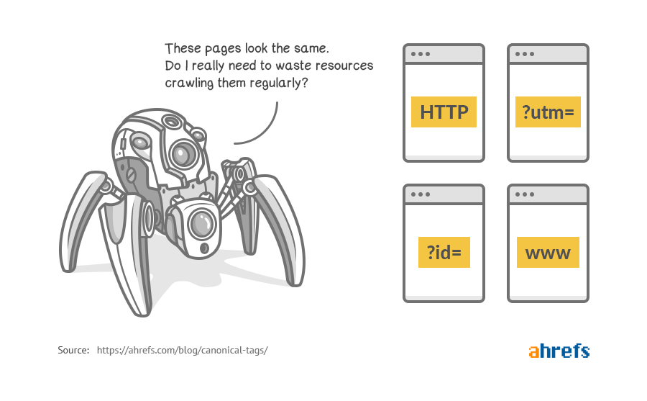

A canonical tag lets Google understand that the URL is the ‘master version’ of the copy of a page. This comes into effect often on ecommerce sites where a particular product may have multiple versions (due to e.g. parameters in the URL). This prevents the risk of being targeted for duplicate content.

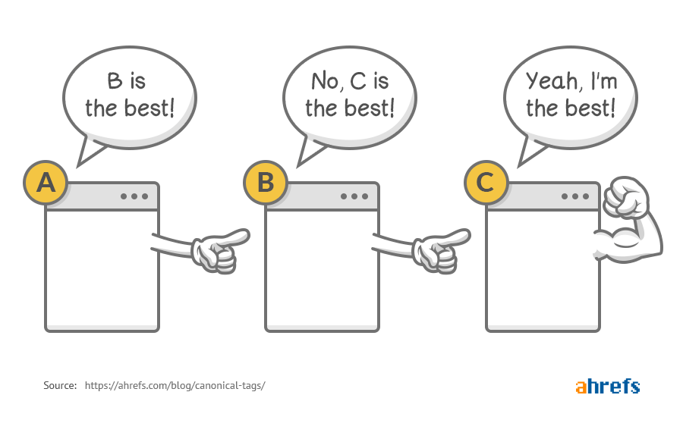
In this section we will look at duplicate content on your site and your use of canonical links by analysing Ahrefs data.

DATA COLLECTION

 | Duplicate content - Pikeland Property Group

FINDINGS

- n/a
- Several city landing pages use a shared title template, which is not automatically a duplicate-content issue if each page is genuinely tailored to its target city. The concern here is that the current title format appears to contain the placeholder-style text [market_state] and is likely too long to display cleanly in search results:
- https://www.pikelandpropertygroup.com/sell-your-house-fast-in-reading-pa/
  - Title: Sell My House Fast Pennsylvania [market_state] - We buy houses in Pennsylvania - Pikeland Property Group
- https://www.pikelandpropertygroup.com/sell-your-house-fast-in-philadelphia-pa/
  - Title: Sell My House Fast Pennsylvania [market_state] - We buy houses in Pennsylvania - Pikeland Property Group
- https://www.pikelandpropertygroup.com/sell-your-house-fast-in-wilmington-de/
  - Title: Sell My House Fast Pennsylvania [market_state] - We buy houses in Pennsylvania - Pikeland Property Group
- https://www.pikelandpropertygroup.com/sell-your-house-fast-in-pittsburgh-pa/
  - Title: Sell My House Fast Pennsylvania [market_state] - We buy houses in Pennsylvania - Pikeland Property Group
- https://www.pikelandpropertygroup.com/sell-your-house-fast-in-phoenixville-pa/
  - Title: Sell My House Fast Pennsylvania [market_state] - We buy houses in Pennsylvania - Pikeland Property Group
- https://www.pikelandpropertygroup.com/sell-your-house-fast-in-coatesville-pa/
  - Title: Sell My House Fast Pennsylvania [market_state] - We buy houses in Pennsylvania - Pikeland Property Group
- https://www.pikelandpropertygroup.com/sell-your-house-fast-in-upper-darby-pa/
  - Title: Sell My House Fast Pennsylvania [market_state] - We buy houses in Pennsylvania - Pikeland Property Group
- https://www.pikelandpropertygroup.com/sell-your-house-fast-in-york-pa/
  - Title: Sell My House Fast Pennsylvania [market_state] - We buy houses in Pennsylvania - Pikeland Property Group
- https://www.pikelandpropertygroup.com/sell-your-house-fast-in-lancaster-pa/
  - Title: Sell My House Fast Pennsylvania [market_state] - We buy houses in Pennsylvania - Pikeland Property Group
- https://www.pikelandpropertygroup.com/sell-your-house-fast-in-pottstown-pa/
  - Title: Sell My House Fast Pennsylvania [market_state] - We buy houses in Pennsylvania - Pikeland Property Group
- Several archive-style pages create lower-priority duplicate-content risk because they are based on category, author, date, or paginated listing templates rather than unique standalone content:
  - Category archives:
    - https://www.pikelandpropertygroup.com/blog/category/sellers/
    - https://www.pikelandpropertygroup.com/blog/category/building-credibility/
    - https://www.pikelandpropertygroup.com/blog/category/buying-mobile-homes/
    - https://www.pikelandpropertygroup.com/blog/category/uncategorized/
    - https://www.pikelandpropertygroup.com/blog/category/selling-mobile-homes/
  - Paginated archive pages:
    - https://www.pikelandpropertygroup.com/blog/category/sellers/page/2/
    - https://www.pikelandpropertygroup.com/blog/author/harrisonpikelandpropertygroup-com/page/2/
    - https://www.pikelandpropertygroup.com/blog/faq-items/page/2/
  - Author archives:
    - https://www.pikelandpropertygroup.com/blog/author/harrisonpikelandpropertygroup-com/
    - https://www.pikelandpropertygroup.com/blog/author/tommy/
  - Date archives:
    - https://www.pikelandpropertygroup.com/blog/2024/05/
    - https://www.pikelandpropertygroup.com/blog/2023/10/
    - https://www.pikelandpropertygroup.com/blog/2024/04/
    - https://www.pikelandpropertygroup.com/blog/2024/01/
    - https://www.pikelandpropertygroup.com/blog/2024/03/
    - https://www.pikelandpropertygroup.com/blog/2023/09/
    - https://www.pikelandpropertygroup.com/blog/2024/02/
    - https://www.pikelandpropertygroup.com/blog/2023/08/
- N/A

RECOMMENDATIONS
- For the city landing pages, do not remove the template approach by default. Instead:
  - Fix the [market_state] placeholder issue.
  - Shorten title tags so they are less likely to truncate.
  - Keep the structure consistent, but make each page locally distinct with city-specific copy, testimonials, FAQs, neighbourhood references, and internal links.
- Noindex low-value archive-style pages that do not have a clear search purpose.
  - This should include date archives, author archives, and thin paginated archive pages.
  - These pages mainly repackage existing blog or FAQ content, so they are unlikely to add unique organic value.
- Keep category archives indexable only if they are useful landing pages.
  - If a category page has unique intro copy, useful internal links, and a clear topic purpose, keep it indexable.
  - If it is only a list of posts, noindex it.
- Specifically:
  - Noindex:
    - /blog/2024/05/
    - /blog/2023/10/
    - /blog/2024/04/
    - /blog/2024/01/
    - /blog/2024/03/
    - /blog/2023/09/
    - /blog/2024/02/
    - /blog/2023/08/
    - /blog/author/harrisonpikelandpropertygroup-com/
    - /blog/author/tommy/
    - /blog/category/sellers/page/2/
    - /blog/author/harrisonpikelandpropertygroup-com/page/2/
    - /blog/faq-items/page/2/
  - Review, then either improve or noindex:
    - /blog/category/sellers/
    - /blog/category/building-credibility/
    - /blog/category/buying-mobile-homes/
    - /blog/category/uncategorized/
    - /blog/category/selling-mobile-homes/
- Remove any noindexed archive URLs from the XML sitemap after changes are made. Keep internal links pointing to useful article pages rather than sending crawl equity into low-value archive pagination.

Structured Data & Rich Results
Google Search works hard to understand the content of a page. You can help by providing explicit clues about the meaning of a page to Google by including structured data.

Structured data is a standardized format for providing information about a page and classifying the page content; for example, on a recipe page, what are the ingredients, the cooking time and temperature, the calories, and so on.

DATA COLLECTION

 | Home page structured data |  | Home page rich results
 | Philadelphia page structured data |  | Philadelphia page rich results
 | About page structured data |  | About page rich results
 | FAQ page structured data |  | FAQ page rich results
 | How We Buy Houses page structured data |  | How We Buy Houses page rich results
 | Contact page structured data |  | Contact page rich results

FINDINGS

- Core schema is present across tested pages.
  - WebPage
  - BreadcrumbList
  - WebSite
  - Organization
  - ImageObject
- The Philadelphia landing page structured data contains unresolved template text.
  - Page title includes [market_state].
  - Meta description includes [market_state].
- The Philadelphia landing page ImageObject appears incomplete.
  - url is blank.
  - contentUrl is blank.
- Dedicated Service schema does not appear to be implemented for the core house-buying service.
- FAQ-style content is visible on key pages, but the detected FAQ schema appears incomplete.
  - Home page visible FAQ example: “What Are the Benefits of Selling My House in Pennsylvania To A Cash Home Buyer?”
  - Home page schema output only shows: “Is Selling a House to A ‘We Buy Houses’ Company in Pennsylvania a Good Idea?”
  - FAQ page visible FAQ examples include: “Will you list my house on the MLS, or will you be the actual buyer?” and “Is there any obligation when I submit my information?”
  - FAQ page schema output only shows: “Is there any obligation when I submit my information?”
  - How We Buy Houses page visible FAQ examples include: “What does ‘as-is’ mean?” and “Is this even legit?”
  - How We Buy Houses page schema output only shows: “Is this even legit?”
- The FAQPage schema appears to include question names without corresponding answer fields in the manual test output.
  - No acceptedAnswer fields were shown in the manual test data supplied.
  - No full list of visible page questions was shown in the detected schema output.

RECOMMENDATIONS
- Fix or remove the incomplete FAQPage schema.
  - If FAQ schema is kept, each marked-up question should match a visible on-page question.
  - Each marked-up question should include a corresponding visible answer.
  - Add the missing acceptedAnswer fields.
  - Include only the FAQs that are visible on that specific page.
- Do not rely on the current FAQ schema until it has been corrected.
  - The visible FAQ accordions are useful, but the structured data output is incomplete.
  - Incomplete FAQPage markup may reduce eligibility for rich result interpretation.
- Add Service schema for the core cash home-buying service.
  - Link it to the existing Organization schema as the provider.
  - Include serviceType, areaServed, description, provider, and URL.
- Fix unresolved template text on the Philadelphia landing page.
  - Replace [market_state] in the title.
  - Replace [market_state] in the meta description.
- Fix the incomplete ImageObject on the Philadelphia landing page.
  - Add a valid image URL.
  - Add a valid contentUrl.
- Re-test the affected pages after implementation.
  - Google Rich Results Test
  - Schema Markup Validator
- Keep the existing baseline schema in place.
  - Organization
  - WebSite
  - WebPage
  - BreadcrumbList
  - ImageObject
- Add Service schema for the main service and location pages.
  - Use it to describe the core offering: buying houses for cash / helping homeowners sell quickly.
  - Include fields such as:
    - name
    - description
    - provider
    - areaServed
    - serviceType
    - url
  - Link the provider back to the existing Organization entity for Pikeland Property Group.
- Fix placeholder text in structured data.
  - Replace [market_state] on the Philadelphia page and any other location pages.
  - Ensure structured data names and descriptions match the final page title, meta description, and visible page content.
- Fix incomplete image schema on the Philadelphia location page.
  - Populate ImageObject fields such as url and contentUrl.
  - Confirm the image URL resolves correctly and matches the primary image used on the page.
- Use FAQ schema only where the FAQ content is visible on the page and matches the marked-up questions and answers.
- Review the SearchAction markup.
  - Keep it only if the site search function works correctly and is intended for Google to understand.
  - Remove or adjust it if the site search is not a meaningful feature.
- Revalidate key templates after changes using both Google’s Rich Results Test and Schema Markup Validator.

Mobile Friendliness
Google has declared that mobile responsiveness is now a factor for ranking in Google search result pages, as a large majority of users access the internet through their mobile devices.

In fact, Google considers the mobile version the PRIMARY version of your website (Mobile first indexing). It is therefore imperative to have a mobile optimized site for healthy search engine rankings.



Source: Google

We use the Google mobile responsive test to see how Google views your website on mobile devices: https://search.google.com/test/mobile-friendly

DATA COLLECTION

 | PageSpeed Insights mobile test  PageSpeed Insights desktop test  GTmetrix performance test

FINDINGS

- Desktop performance is strong in the latest US PageSpeed Insights test.Desktop Performance score: 97.
  - Desktop First Contentful Paint: 0.7s.
  - Desktop Largest Contentful Paint: 1.2s.
  - Desktop Speed Index: 0.7s.
  - Desktop Total Blocking Time: 40ms.
  - Desktop Cumulative Layout Shift: 0.
- GTmetrix also reports strong performance under its test conditions.Performance score: 99%.
  - Structure score: 96%.
  - Largest Contentful Paint: 767ms.
  - Total Blocking Time: 26ms.
  - Cumulative Layout Shift: 0.
- The homepage is responsive, but the latest US PageSpeed Insights test shows a clear mobile performance issue.Mobile Performance score: 57.
  - Mobile First Contentful Paint: 8.3s.
  - Mobile Largest Contentful Paint: 11.4s.
  - Mobile Speed Index: 8.3s.
  - Mobile Total Blocking Time: 90ms.
  - Mobile Cumulative Layout Shift: 0.
- The main performance concern is mobile loading speed rather than layout stability or JavaScript blocking.
  - CLS is 0 on both mobile and desktop.
  - TBT is within an acceptable range on both mobile and desktop.
  - Mobile FCP and LCP are the weak points.
- PageSpeed highlights unused JavaScript as the largest optimisation opportunity.
  - Estimated unused JavaScript savings: 362KB.
  - The flagged scripts are primarily Google reCAPTCHA resources.
  - Lighthouse recommends delaying JavaScript execution through WP Rocket where appropriate.
- PageSpeed also flags smaller optimisation opportunities.
  - Unused CSS, with estimated savings of 82KB on mobile and 88KB on desktop.
  - Inefficient cache lifetimes, with estimated savings of 19KB on mobile and 21KB on desktop.
  - Image delivery improvements, with estimated savings of 10KB on mobile.
  - DOM size optimisation.
- Accessibility remains good overall, but there are still technical issues to fix.
  - Accessibility score: 92.
  - Some text and button elements have insufficient colour contrast.
  - SVG map links do not have discernible names.
  - One heading skips the expected heading order.
- SEO remains strong overall, with one minor link-text issue.
  - SEO score: 92.
  - One link to /faq/ uses non-descriptive anchor text: “here”.
- Best Practices score is strong, but Lighthouse flags security header opportunities.
  - Best Practices score: 96.
  - No CSP found in enforcement mode.
  - No HSTS header found.
  - No frame control policy found.
  - No COOP header found.
- Agentic Browsing is still partially failing.
  - Mobile score: 1/2.
  - Desktop score: 1/2.
  - The accessibility tree is not well-formed because some SVG links do not have discernible text.
- Sign-up, results, recover PIN, terms, and contact-support journeys should be tested on real mobile devices because these are important conversion and support paths.
- Links from the classic mobile interface should point directly to final URLs rather than redirecting through SwitchUI or non-trailing-slash variants.
- Remove unnecessary intermediate steps in mobile account and game-selection flows.
- Make form requirements and next steps clear before users submit details.

RECOMMENDATIONS
- Prioritise mobile load speed improvements.
  - Focus on reducing mobile FCP and LCP.
  - Treat desktop performance as a lower priority because the latest US desktop test is already strong.
- Review Google reCAPTCHA loading.
  - Delay reCAPTCHA scripts until a form is visible or interacted with, if technically possible.
  - Avoid loading duplicate reCAPTCHA resources.
  - Test all lead forms after any reCAPTCHA optimisation.
- Reduce unused JavaScript and CSS.
  - Use WP Rocket delay/defer settings carefully.
  - Remove unused plugin or theme assets from the homepage where possible.
  - Keep conversion-critical form scripts excluded from aggressive delay rules if needed.
- Improve mobile above-the-fold loading.
  - Confirm the LCP element on mobile.
  - Optimise and preload the LCP image or hero asset if applicable.
  - Ensure critical CSS needed for above-the-fold rendering is available early.
- Keep CLS protections in place.
  - Maintain fixed dimensions or reserved space for images, forms, review widgets, maps, and CTA sections.
- Fix Lighthouse accessibility issues.
  - Add accessible names to SVG map links.
  - Improve colour contrast for flagged text and CTA elements.
  - Review the skipped heading level.
- Fix the minor SEO link text issue.
  - Replace the “here” link to /faq/ with descriptive text such as “read our FAQ”.
- Review security headers separately from performance.
  - Add or strengthen CSP where safe.
  - Add HSTS after confirming HTTPS is stable across the full site.
  - Add frame protection through X-Frame-Options or CSP frame-ancestors.
  - Review COOP only after checking whether third-party scripts or embedded tools are affected.

Speed Test & Performance
Google has stated that page loading speed is an SEO ranking signal. Furthermore, it affects user experience - slow sites are horrible to use. You can boost your site speed by using a CDN, compressing images, and switching to faster hosting.

 | CDN  CDN is short for content delivery network, which is a system of distributed servers (network) that deliver pages and other web content to a user, based on the geographic locations of the user, the origin of the webpage and the content delivery server. This service is effective in speeding the delivery of content of websites with high traffic and websites that have global reach.

Here’s an image from CloudFlare which depicts this perfectly:
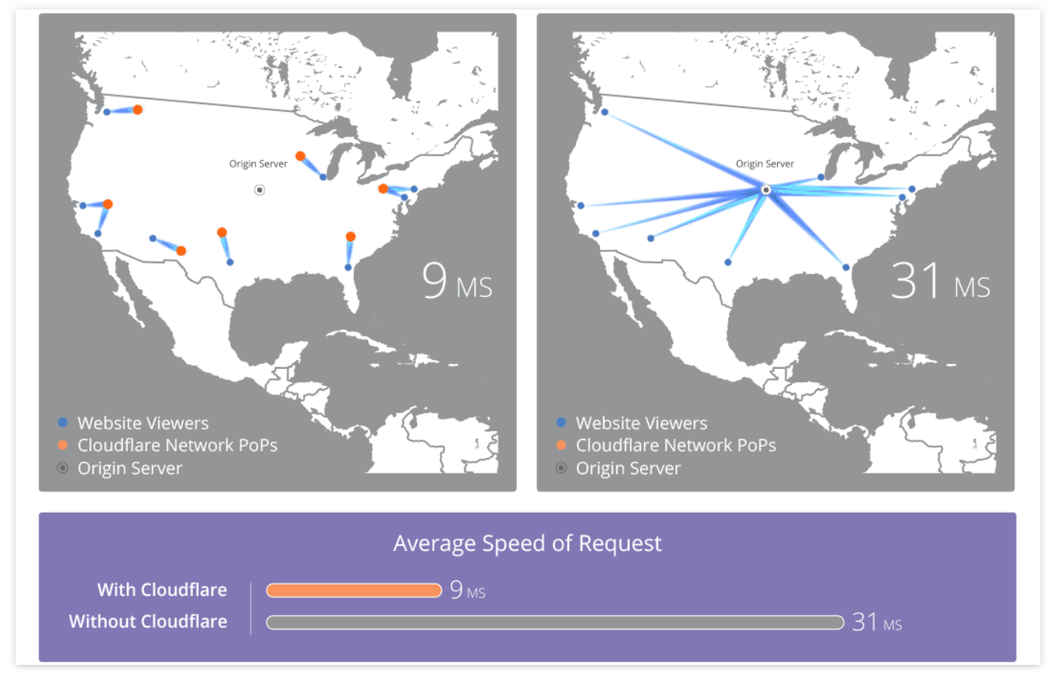
By using a CDN, like CloudFlare, when someone visits your website, the images will be loaded from the server closest to them.

We want to make sure your site doesn’t take more than 4 seconds to load: MunchWeb found that 75% of users wouldn’t re-visit a site that took longer than 4 seconds to load.

FINDINGS

Here are the current Pingdom test results for the home page:

Test Source | Score / Grade | Page Size | Requests | Load / Key Timing | Notes
PageSpeed Insights Mobile | 57 Performance | n/a | n/a | LCP 11.4s, FCP 8.3s | Weakest result; mobile throttling exposes slow above-the-fold loading.
PageSpeed Insights Desktop | 97 Performance | n/a | n/a | LCP 1.2s, FCP 0.7s | Strong desktop result.
GTmetrix | 99% Performance, 96% Structure | n/a | n/a | LCP 767ms, TBT 26ms, CLS 0 | Strong result under GTmetrix test conditions.
Pingdom | 85 - B | 3.14MB | 99 | Fully loaded 1.27s | Heavier crawl view; includes 74 image requests and repeated reCAPTCHA assets.
Webpagetest | n/a | 1.84MB | 29 | Fully loaded 1.50s, LCP 804ms | Lighter first-view result; shows low TBT but some CLS at 0.165.

*Pingdom test run from the United States server.

- Desktop and non-throttled synthetic tests are strong.
  - Desktop First Contentful Paint: 0.7s.
  - Desktop Largest Contentful Paint: 1.2s.
  - Desktop Total Blocking Time: 40ms.
  - GTmetrix Largest Contentful Paint: 767ms.
  - GTmetrix Cumulative Layout Shift: 0.
- Synthetic performance results are mixed depending on test conditions.
  - PageSpeed Insights mobile score: 57.
  - PageSpeed Insights desktop score: 97.
  - GTmetrix Performance score: 99%.
  - Pingdom HAR fully loaded time: 1.27s.
  - Synthetic JSON fully loaded time: 1.50s.
- The main issue is mobile loading speed under PageSpeed’s throttled mobile test.
  - Mobile First Contentful Paint: 8.3s.
  - Mobile Largest Contentful Paint: 11.4s.
  - Mobile Speed Index: 8.3s.
  - Mobile Total Blocking Time: 90ms.
  - Mobile Cumulative Layout Shift: 0.
- The HAR export shows 99 requests and 3.14MB transferred.
  - Images: 74 requests, 1.38MB.
  - Scripts: 5 requests, 756KB.
  - Fonts: 14 requests, 330KB.
  - Documents: 2 requests, 304KB.
- The synthetic JSON export shows a lighter first-view result than the HAR.
  - 29 requests.
  - 1.84MB transferred.
  - First Contentful Paint: 804ms.
  - Largest Contentful Paint: 804ms.
  - Total Blocking Time: 8ms.
- Google reCAPTCHA is the largest script weight.
  - recaptcha__en.js is loaded more than once.
  - The reCAPTCHA resources account for roughly 746KB in the synthetic JSON export.
  - PageSpeed also flags 362KB of unused JavaScript, mainly from Google reCAPTCHA.
- First-party image weight is still a meaningful contributor.
  - we-buy-houses-pa.jpg is around 249KB.
  - sell-my-house-fasts-pennsylvania-scaled.jpg is around 194KB.
- First-party Pikeland assets are not identified as being served through a CDN in the synthetic export.
  - Google and Akamai CDN are used for third-party resources such as reCAPTCHA, Google fonts, and Typekit.
  - Pikeland-hosted images, fonts, and HTML are served directly from www.pikelandpropertygroup.com.
- Cache headers are generally strong for many static assets.
  - Several fonts use public, max-age=31536000.
  - Key first-party images use long cache lifetimes.
  - The homepage HTML uses max-age=0, which is expected for an HTML document.
- n/

RECOMMENDATIONS
- Prioritise mobile performance, not desktop performance.
  - Desktop and synthetic tests are already strong.
  - Mobile PageSpeed remains the weakest performance signal.
- Delay or conditionally load Google reCAPTCHA.
  - Load reCAPTCHA only when a form is visible or when the user interacts with a form.
  - Check whether duplicate reCAPTCHA scripts can be removed.
  - Retest all Gravity Forms after making this change.
- Reduce homepage JavaScript weight.
  - Use WP Rocket delay/defer settings where safe.
  - Exclude only conversion-critical scripts from delay rules.
  - Remove unused plugin scripts from the homepage where possible.
- Optimise first-party images further.
  - Compress large JPG assets.
  - Convert suitable images to WebP or AVIF.
  - Serve correctly sized mobile image variants.
  - Confirm the mobile LCP image and preload it if appropriate.
- Consider serving first-party static assets through a CDN.
  - Prioritise images, CSS, JavaScript, and fonts.
  - This is most useful if the site targets users across multiple US regions.
- Keep current cache rules for static assets.
  - Long cache lifetimes are already present for many fonts and images.
  - Continue using versioned filenames so cached assets can be safely refreshed.
- Maintain CLS protections.
  - CLS is currently 0 in PageSpeed and GTmetrix.
  - Preserve fixed dimensions or reserved space for images, forms, review widgets, and CTA modules.

Security Check & Malware Scan
Often a large drop in rankings occurs when a site is hacked with Malware. The hackers use your site to generate hundreds of spammy links and pages advertising unsavoury products such as payday loans or viagra pills.



FINDINGS

We ran your site through Google Security and Sucuri Scans. These are services which check for malware and hacks.

- Using Sucuri, we did not detect malware or obvious site compromise.
  - No malware found.
  - No injected spam detected.
  - No defacements detected.
  - No internal server errors detected.
- The domain is not blacklisted by the security databases checked by Sucuri.
  - Google Safe Browsing: clean.
  - McAfee: clean.
  - Sucuri Labs: clean.
  - ESET: clean.
  - PhishTank: clean.
  - Yandex: clean.
  - Opera: clean.
- The site is running on WordPress and Nginx.
  - IP address: 207.148.28.80.
  - CMS detected: WordPress 7.0.
  - Server detected: Nginx.
- There are several security hardening opportunities.
  - No website application firewall detected.
  - SPF record should be reviewed or added to reduce email spoofing risk.
  - Clickjacking protection header is missing.
  - Content type sniffing protection header is missing.
  - Strict-Transport-Security header is missing.
  - Content-Security-Policy directives are missing.
- N/A

RECOMMENDATIONS
- No malware clean-up is required based on the Sucuri scan.
  - Continue regular security monitoring.
  - Re-scan after plugin, theme, or WordPress updates.
- Add a website application firewall if not already provided elsewhere.
  - Use a cloud-based WAF or hosting-level WAF.
  - Enable protection against common WordPress attacks and DDoS traffic.
- Add or review the SPF record for the domain.
  - Include all legitimate email-sending services.
  - Avoid overly broad SPF rules.
- Add missing security headers.
  - Add Strict-Transport-Security after confirming HTTPS works across the full site.
  - Add X-Content-Type-Options: nosniff.
  - Add clickjacking protection through X-Frame-Options or CSP frame-ancestors.
  - Add a Content-Security-Policy gradually, starting in report-only mode if needed.
- Keep WordPress, plugins, and themes patched.
  - Remove unused plugins and themes.
  - Keep regular backups in place.

Website Structure & Depth
Ideally you want a flat website structure. This means that ideally it should not take more than 3 clicks to go from your homepage to any page on your site. After all, if your ‘money page’ has to be reached by clicking (say) 8 times, then not that many people will end up getting to it. In order to analyse this for your site, we visually represent your website structure using a tool called Visual Site Mapper. We use Ahrefs data to further analyse page depth.

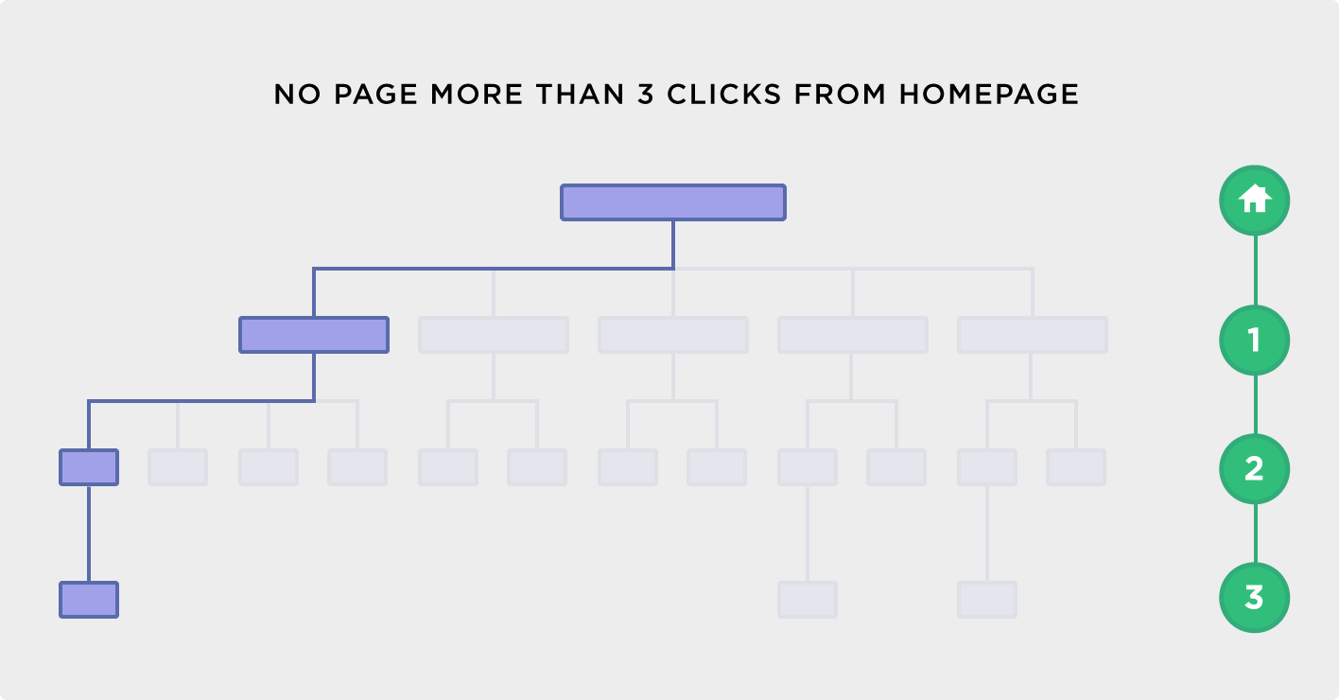

FINDINGS

- The site does not show a major crawl-depth issue for pages found in the crawl.
  - The deepest HTML page found in the crawl data is at depth 3.
  - No indexable 200 HTML pages were found deeper than 3 clicks in the crawl data.
- Key navigation pages have internal links.
  - Homepage: 90 href inlinks.
  - How We Buy Houses: 89 href inlinks.
  - Contact: 89 href inlinks.
  - Reviews: 89 href inlinks.
  - About Us: 89 href inlinks.
  - Get Your Offer: 89 href inlinks.
  - FAQ: 89 href inlinks.

- The current site structure is relatively shallow, but several commercially valuable pages are not well supported by internal linking.
  - Priority city landing pages are indexable and included in the sitemap, but have 0 href inlinks in the crawl.
  - Several important commercial/location pages have 0 href inlinks.
    - https://www.pikelandpropertygroup.com/sell-your-house-fast-in-reading-pa/
    - https://www.pikelandpropertygroup.com/sell-your-house-fast-in-philadelphia-pa/
    - https://www.pikelandpropertygroup.com/sell-your-house-fast-in-wilmington-de/
    - https://www.pikelandpropertygroup.com/sell-your-house-fast-in-pittsburgh-pa/
    - https://www.pikelandpropertygroup.com/sell-your-house-fast-in-phoenixville-pa/
    - https://www.pikelandpropertygroup.com/sell-your-house-fast-in-coatesville-pa/
    - https://www.pikelandpropertygroup.com/sell-your-house-fast-in-upper-darby-pa/
    - https://www.pikelandpropertygroup.com/sell-your-house-fast-in-york-pa/
    - https://www.pikelandpropertygroup.com/sell-your-house-fast-in-lancaster-pa/
    - https://www.pikelandpropertygroup.com/sell-your-house-fast-in-pottstown-pa/
- Other indexable 200 pages also have 0 href inlinks.
  - https://www.pikelandpropertygroup.com/sell-house-awn/
  - https://www.pikelandpropertygroup.com/resource-page/
  - https://www.pikelandpropertygroup.com/terms-of-user/
  - https://www.pikelandpropertygroup.com/thank-you/contact/
  - https://www.pikelandpropertygroup.com/house-information/
  - https://www.pikelandpropertygroup.com/compare/
  - https://www.pikelandpropertygroup.com/avoiding-foreclosure/
  - https://www.pikelandpropertygroup.com/thank-you/
- Current sitemap
  - Proposed sitemap
  - Relume of proposed sitemap
- N/A

RECOMMENDATIONS
- Add a dedicated Locations hub.
  - Proposed URL: https://www.pikelandpropertygroup.com/locations/
  - Link to it from the homepage, navigation, footer, or key commercial sections.
  - Link from the hub to each priority city landing page.
- Use the proposed sitemap to improve internal linking, not just URL organisation.
  - Add contextual links from the homepage, How We Buy Houses page, FAQ page, Reviews page, and relevant blog posts to priority commercial pages.
- Keep priority city pages close to the homepage.
  - Ensure key city pages are reachable within 1-2 clicks.
  - Prioritise Philadelphia, Reading, Lancaster, York, Pittsburgh, and Wilmington if these are confirmed target markets.
- Review proposed URL changes before implementation.
  - The proposed location URL changes are intended to align the site structure with the keyword research from the content audit.
  - The current location URLs use the pattern /sell-your-house-fast-in-city-state/, while the proposed URLs use a cleaner keyword-led structure around sell my house fast + city + state.
  - Example proposed changes:
    - /sell-your-house-fast-in-philadelphia-pa/ to /locations/sell-my-house-fast-philadelphia-pa/
    - /sell-your-house-fast-in-reading-pa/ to /locations/sell-my-house-fast-reading-pa/
    - /sell-your-house-fast-in-lancaster-pa/ to /locations/sell-my-house-fast-lancaster-pa/
    - /sell-your-house-fast-in-york-pa/ to /locations/sell-my-house-fast-york-pa/
    - /sell-your-house-fast-in-pittsburgh-pa/ to /locations/sell-my-house-fast-pittsburgh-pa/
    - /sell-your-house-fast-in-wilmington-de/ to /locations/sell-my-house-fast-wilmington-de/
  - These changes support keyword themes identified in the content audit, including terms such as sell my house fast reading pa, we buy houses reading pa, sell my house fast lancaster pa, cash home buyers lancaster pa, sell my house fast york pa, and sell my house fast pittsburgh pa.
  - If the URLs are changed, map each old URL to its new URL with a 301 redirect.
  - Update internal links, canonical tags, XML sitemap URLs, structured data URLs, and Google Search Console sitemap submissions at the same time.
  - Only change URLs where there is a clear SEO or structural benefit; avoid changing stable URLs purely for aesthetics.

________________

Content Management System
This section deals with sitewide problems which can occur due to problems specific to your Content Management System (CMS). These problems revolve around using outdated versions of the CMS and plugins, as well as lacking important plugins (ie. Yoast for WordPress).
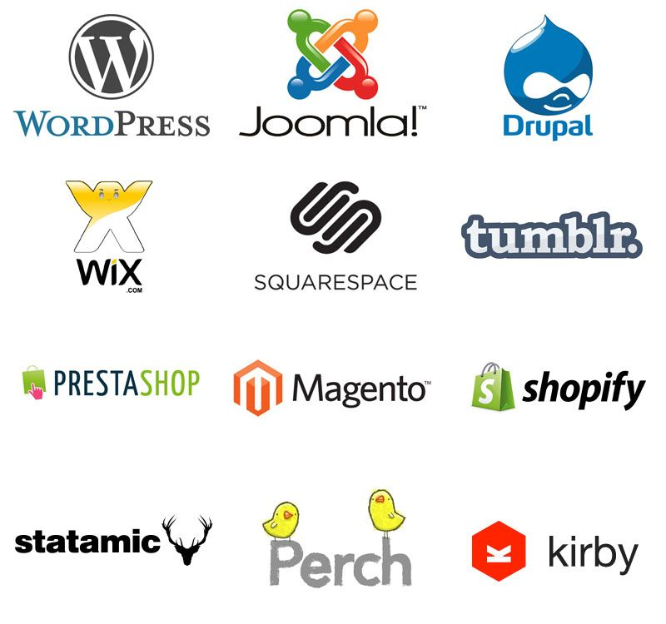



lCONTENTl lMANAGEMENTl lSYSTEMl

General CMS
It's important to keep your CMS Core up-to-date. CMS updates include important performance and security fixes, which ensures that your site loads quickly and is secure from vulnerabilities.

FINDINGS

- Wordpress core + 26/28 plugins up to date
- n/a
- n/a

RECOMMENDATIONS
- n/a

Yoast
Yoast SEO is a powerful Wordpress plugin that helps in optimizing your site. While it might not be essential in the strictest sense of the word, it is highly recommended.

FINDINGS

- Yoast up to date and first time configuration completed (Site representation, social profiles, etc)
- n/a
- n/a

RECOMMENDATIONS
- n/a

Plugins
Over time most websites accumulate a number of plugins to enhance some aspect of the website or make some task easier. Some plugins will have security issues which crop up and are fixed by the plugin creator, and so it is important to monitor your plugins and keep them up-to-date.

FINDINGS

- N/A
- HandL UTM Grabber v3 needs minor version update (3.1.20 > 3.1.22)
- WP Rocket needs major update (3.21.3 > 3.23)

RECOMMENDATIONS
- Update plugins:
  - HandL UTM Grabber v3 needs minor version update (3.1.20 > 3.1.22)
  - WP Rocket needs major update (3.21.3 > 3.23)


Summary and Conclusion
lSUMMARY &l lCONCLUSIONl
From a technical SEO perspective, Pikeland Property Group has a stable foundation. The domain is branded, uses an appropriate .com TLD, resolves over HTTPS, has an active SSL certificate, and does not show evidence of malware or blacklist issues. The site also has a functioning 404 page, a valid robots.txt file, and strong desktop performance in PageSpeed Insights and GTmetrix.
The main technical constraints are not severe sitewide errors, but signal consistency and crawl-quality issues.
The audit identified sitemap inconsistencies, indexable low-value URLs, avoidable redirected URLs in sitemap-related exports, incomplete structured data, duplicate-content risks, and important commercial/location pages with 0 href inlinks.
Crawl depth itself is not a major concern, as no indexable 200 HTML pages were found deeper than three clicks, but several valuable pages are discoverable through the sitemap rather than being properly supported by internal links.
Performance is mixed. Desktop results are strong, but the latest US PageSpeed Insights mobile test shows weak mobile loading performance, particularly FCP and LCP. Google reCAPTCHA, unused JavaScript, and above-the-fold loading should therefore be treated as key mobile optimisation priorities.
Overall, the site is not in poor technical condition, but it needs cleanup and consolidation. The priority should be to strengthen internal linking to commercial pages, clean the sitemap, reduce low-value indexable URLs, fix broken and redirected URL signals, improve structured data accuracy, optimise mobile loading speed, and apply WordPress/security hardening.

Areas for Improvement
Here we will discuss the sections of this audit: focusing on whether your website is healthy or whether it has problems, and what actions we suggest you take to address the problems.

Domain
DOMAIN | 0+ suggested actions
The domain setup is mostly healthy. HTTPS is active, the preferred www version is used across the crawl, and there is no evidence of malware or blacklist issues.

Areas for improvement
- Ensure all internal links, canonicals, structured data URLs, and sitemap references use https://www.pikelandpropertygroup.com/.
- Keep HTTP-to-HTTPS redirects in place and monitor after future releases.

Recommended actions
- Update any remaining alternate hostname references if found during future crawls.
- Recheck preferred-domain consistency after sitemap, plugin, or theme changes.

301 Redirects & 404 Errors
301 REDIRECTS & 404 ERRORS | 6 suggested actions
Redirect and 404 issues are limited, but avoidable redirected URLs and broken internal references should be cleaned up to improve crawl efficiency and user experience.

Areas for improvement
- Redirected Fusion Builder and element category URLs appear in sitemap-related exports.
- Some internal links point to URLs that redirect rather than final 200 URLs.
- Internal links point to /stop-foreclosure/, which returns a 404.
- FAQ category canonical issues point to 404 URLs.
- Redirected and broken URLs create unnecessary crawl waste.
- 404 handling works, but recovery options can still be improved.

Recommended actions
- Remove redirected Fusion Builder and element category URLs from the XML sitemap.
- Update internal links so they point directly to final 200 URLs.
- Fix internal links pointing to /stop-foreclosure/.
- Correct FAQ category canonical targets that point to 404 URLs.
- Keep HTTP-to-HTTPS redirects in place.
- Re-crawl the site after fixes to confirm no new redirect chains or 404s remain.

Google
GOOGLE | 5+ suggested actions
Areas for improvement
- Google Tag Manager is not set up.
- Mobile usability issues are flagged in Search Console.
- Core Web Vitals reporting and diagnostics are limited due to the recent GSC setup.
- Domain and sitemap signals are not fully aligned across Google properties.

Recommended actions
- Implement Google Tag Manager (GTM)
- Create a GTM container for the site.
- Migrate existing GA4 tracking into GTM
- Configure baseline events (page_view, scroll, outbound_clicks) and prepare for conversion tracking.

- Complete Google Search Console (GSC) setup
- Submit the regenerated XML sitemap containing only preferred-domain URLs.
- Review Coverage and Indexing reports to confirm correct page indexing.

- Enable reliable Core Web Vitals monitoring
- Link Google Search Console to GA4

- Align Google property signals
- Ensure the sitemap submitted in GSC matches the preferred domain and canonical URLs.
- Confirm GA4 data streams and settings reference the correct domain.

Technical SEO
TECHNICAL SEO | 6 suggested actions
The biggest technical SEO priorities are sitemap quality, indexation control, internal linking, duplicate-content risk, canonical clarity, and structured data accuracy.

Areas for improvement
- The XML sitemap includes URLs that should be reviewed or removed.
- Some low-value archive pages are indexable.
- Several commercial city pages are indexable and in the sitemap but have 0 href inlinks.
- Duplicate-content risks exist across archive pages, duplicate landing pages, and repeated title templates.
- Some city page titles/descriptions contain unresolved [market_state] text.
- FAQ and Service structured data should be made more complete and accurate.

Recommended actions
- Clean the XML sitemap so it includes only canonical, indexable, 200 URLs.
- Disable unnecessary Fusion Builder, element category, author, and low-value archive sitemaps where appropriate.
- Add internal links to priority city and service pages that currently have 0 href inlinks.
- Noindex low-value archive pages that are not intended to rank.
- Fix unresolved [market_state] text in city page titles and descriptions.
- Add accurate Service schema and repair incomplete FAQPage schema where visible FAQ content supports it.

PERFORMANCE & MOBILE | 5 suggested actions
Desktop performance is strong, but mobile PageSpeed results show poor loading speed under mobile throttling.

Areas for improvement
- Mobile PageSpeed Performance score is weaker than desktop.
- Mobile FCP and LCP are the main performance issues.
- Google reCAPTCHA contributes significant unused JavaScript.
- Some unused CSS and JavaScript are loaded on the homepage.
- First-party images can be further optimised for mobile delivery.

Recommended actions
- Prioritise mobile FCP and LCP improvements.
- Delay or conditionally load Google reCAPTCHA where possible.
- Reduce unused JavaScript and CSS from theme/plugin assets.
- Optimise first-party images and serve correctly sized mobile variants.
- Preload the mobile LCP image if appropriate.

WORDPRESS | 6 suggested actions
The site runs on WordPress and appears generally stable, but WordPress theme/plugin management should be tightened to reduce performance, security, and crawl-quality risks.

Areas for improvement
- WordPress, theme, and plugin assets contribute to unused CSS and JavaScript.
- Google reCAPTCHA appears to load heavily and may be tied to form/plugin configuration.
- WordPress-generated archive, author, taxonomy, and Fusion Builder URLs are creating low-value crawl/indexation signals.
- Sitemap output appears to include some URLs that should not be submitted to search engines.
- Security headers and WAF protection are not fully hardened.
- Ongoing plugin and theme updates should be monitored to prevent regressions
Recommended actions
- Audit active plugins and remove anything unused or duplicated.
- Configure SEO plugin sitemap settings to exclude low-value taxonomies, author archives, and non-indexable URLs.
- Review Avada/Fusion Builder taxonomy outputs and disable public indexing where they are not needed.
- Use WP Rocket carefully to delay/defer non-critical JavaScript while protecting form functionality.
- Keep WordPress core, themes, and plugins updated, with backups before updates.
- Add security hardening through WAF protection, security headers, and least-privilege admin access.

SECURITY | 5 suggested actions
No malware or blacklist issues were detected, but security hardening can be improved.

Areas for improvement
- No website application firewall was detected by Sucuri.
- SPF should be reviewed or added for the domain.
- HSTS is missing.
- Clickjacking protection is missing.
- Content-Security-Policy and content-type sniffing protection are missing.
Recommended actions
- Add a website application firewall if one is not already active at hosting level.
- Add or review SPF records for the domain.
- Add Strict-Transport-Security once HTTPS coverage is confirmed.
- Add X-Content-Type-Options: nosniff.
- Add clickjacking protection through X-Frame-Options or CSP frame-ancestors.


Appendices
lAPPENDICESl

Appendix: References and resources
This audit is made possible due to the research and efforts of Google and the SEO community.
Here are a number of incredible tools, articles and resources that we used to develop and perform this audit.

https://www.digicert.com/ssl/
https://analytics.google.com
https://search.google.com
https://tools.pingdom.com/
https://gtmetrix.com/
https://www.webpagetest.org/
https://transparencyreport.google.com
https://yoast.com/
https://yoast.com/meta-descriptions/
https://sitecheck.sucuri.net
https://ahrefs.com/
http://www.copyscape.com/
https://www.gotchseo.com/seo-audit/
https://neilpatel.com/blog/seo-website-audit/
https://backlinko.com/google-ranking-factors
https://backlinko.com/seo-site-audit
https://backlinko.com/on-page-seo
https://backlinko.com/link-building-strategies
https://www.searchenginejournal.com/the-ultimate-seo-audit-checklist/
https://www.thehoth.com/blog/google-medic-update/
https://barracuda.digital/panguin-seo-tool/
https://www.reliablesoft.net/seo-checklist/
https://www.google.com/business

